Everything contained in this directory is to analyze and problem-solve the strange distribution observed in the focal plane created by G4EMMA simulations (the pattern can be seen in the diagram).

The pattern was created by the input conditions found in this directory within another directory called “conditions,” and was done by the EMMA application as of August 15, 2017.

The pattern was produced by firing 25,000 particles of Ar 14+ at a gold target. The spectrometer was set to detect for particles of charge 13.5+, so the 14+ beam appears on the right side of the focal plane.

Energy loss was calculated using the tool found at <http://davids24.triumf.ca/~oliver/NUTEMMA/home.html>

The diagram below cuts the distribution in to several sectors cut by the lines labelled Xn and Yn. For each sector, a distribution was made to observe key aspects. The areas are labelled.

Each sector has a page in the “Data.xslx” excel file where the information regarding all the events (particle hits on the focal plane) in that sector is displayed. This information has eight categories, arranged correspondingly in Excel:

|  |  |  |  |  |  |  |  |
| --- | --- | --- | --- | --- | --- | --- | --- |
| Kinetic Energy at Focal Plane | Kinetic Energy Leaving the Target | Polar Angle at Focal Plane | Polar Angle Leaving the Target | X Position at Focal Plane | X Position Leaving the Target | Y Position at the Focal Plane | Y Position Leaving the Target |

The data from each excel sheet is then processed into a collection of histograms visible in the LoggerPro (.cmbl) file.

In the separate Excel and LoggerPro files named “XY angle analysis,” I later printed two additional columns after the “Angle Leaving the Target” or “T Angle” column. They are the X and Y – components of the direction vector that represents the particle leaving the target (the Z-axis is normal to the target). This way, we can see how much angular deviation in the X or Y direction, not just in a general radial cone like the previous value of “Angle” represents.

Analysis of these parameters are done in Excel and LoggerPro files titled “XY angle analysis”

|  |  |  |  |  |  |  |  |
| --- | --- | --- | --- | --- | --- | --- | --- |
| Kinetic Energy at Focal Plane | Kinetic Energy Leaving the Target | Angle at Focal Plane | Angle Leaving the Target | X Position at Focal Plane | X Position Leaving the Target | Y Position at the Focal Plane | Y Position Leaving the Target |

The files titled “X angle analysis” are analysis of the azimuthal angle between the particle’s momentum vector’s projection on the x-z plane and the z axis.

The values of Xn and Yn are:

|  |  |
| --- | --- |
| X1 | 27.0 |
| X2 | 32.0 |
|  |  |
| Y1 | 7.0 |
| Y2 | 3.0 |
| Y3 | -3.0 |
| Y4 | -7.0 |

The plots were created on LoggerPro with data from fp_beam.dat.

As of August 31, 2017, a bunch of data processing has been done, but no conclusion has so far been found.

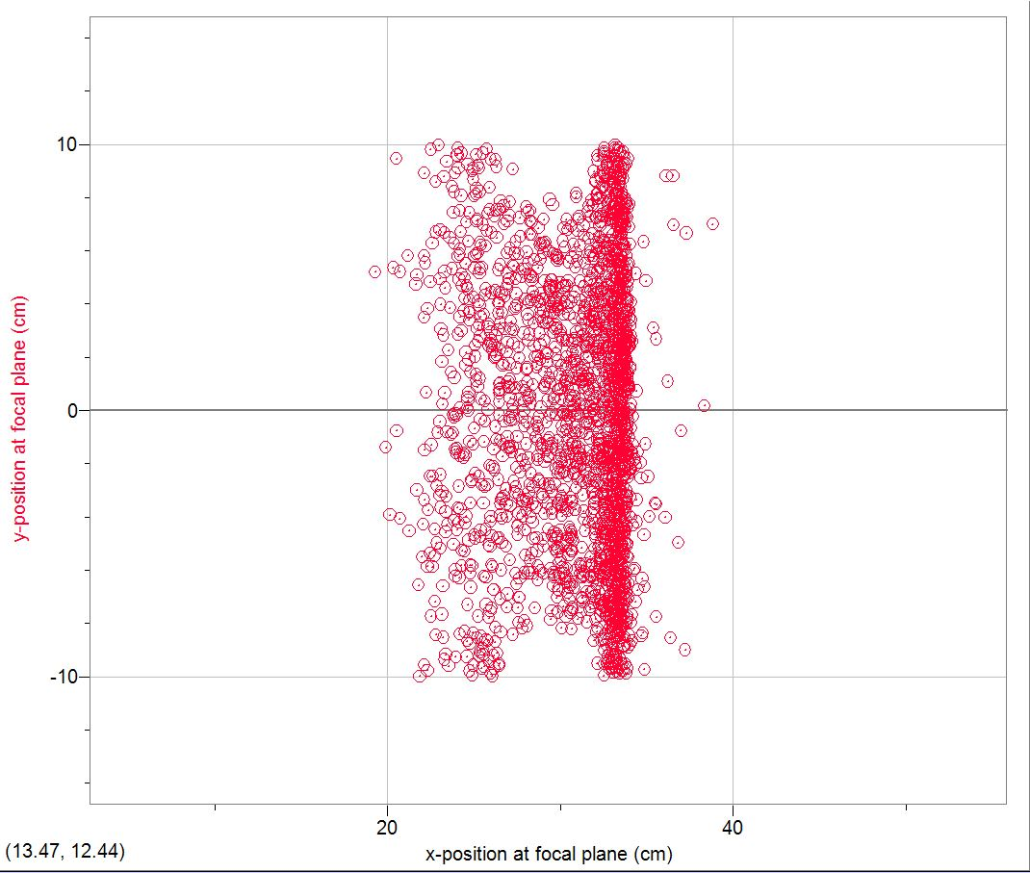

Y1`

Y2

Y3

Y4

X1

X2

L1

L2

R1

R3

L3

R2

C1

R4

R5

C5

L5

L4

C2

C3

C4

Figure : Diagram

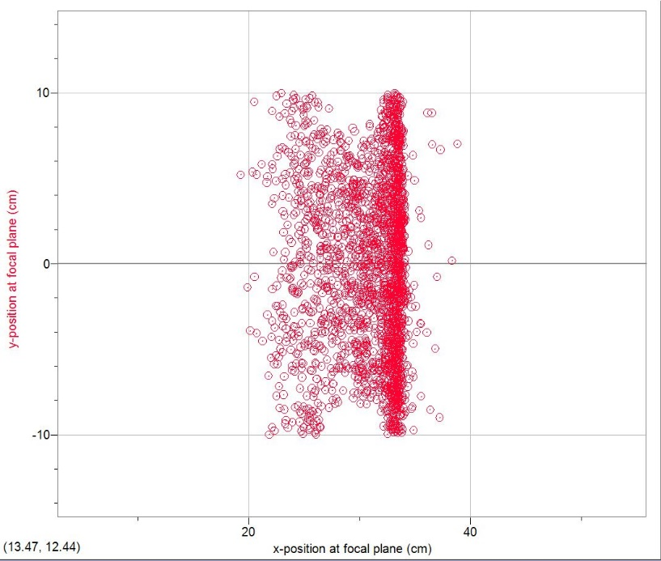

Figure : The original focal plane hit pattern. Strange, eh?